Work in pairs to find all the answers from the bubbles below:
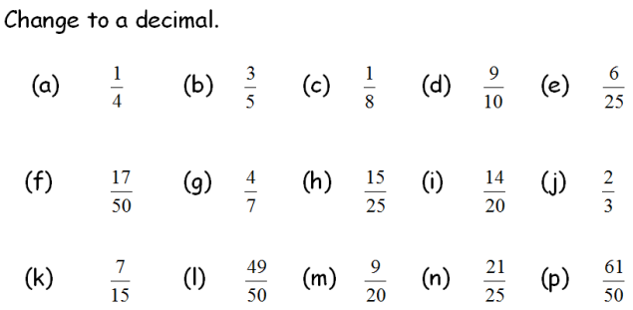

In pairs, see who can total the highest score by changing these decimals into percentages. You can only add the percentages you get correct!
Keep our score on the right hand columns. Write your names at the top.-------->
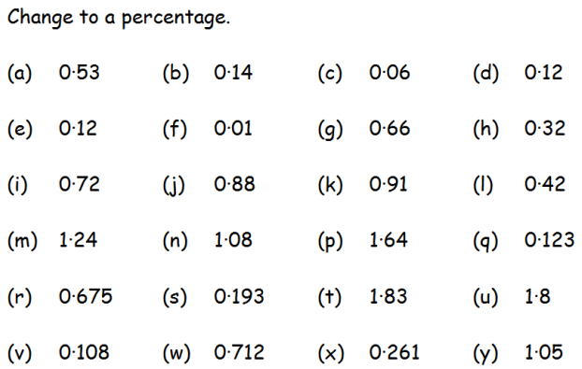

Colour in the fractions on the fraction trail to find out which game Tom is annoyed with.
