Exam style questions E3
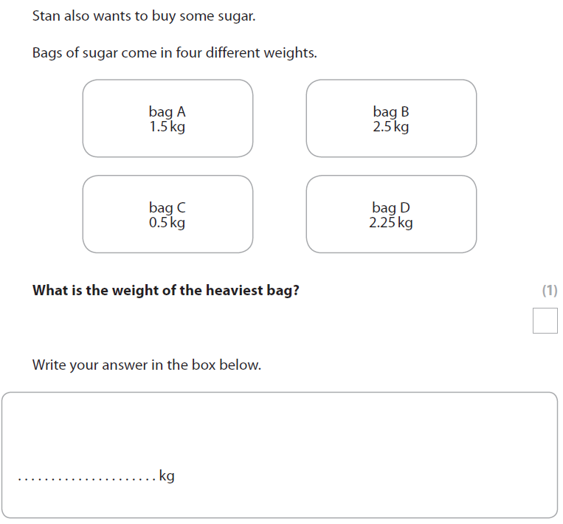
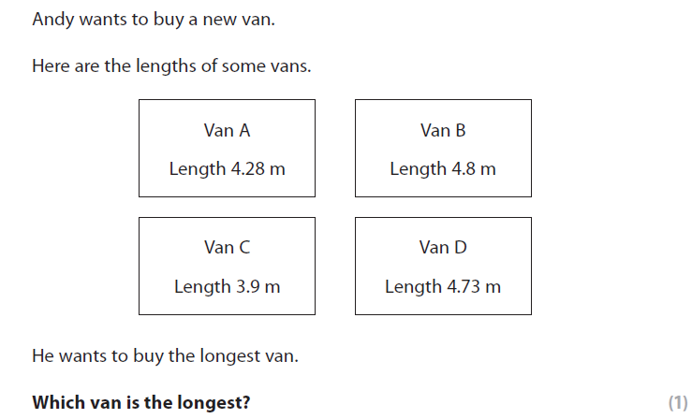
Exam Questions L1
Q1. Nav draws a pie chart after the car boot sales.
The pie chart shows where the money from the car boot sales is going.
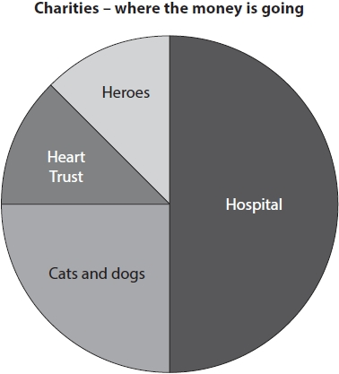
Nav wants to write a comment about which charities the money is going to.
(c) Use the information from the pie chart to write a comment for Nav.
(1)
Write your comment in the space below.

Q2.
Mr Khan is the manager of The Palace.
He records the number of hours each person worked last week.
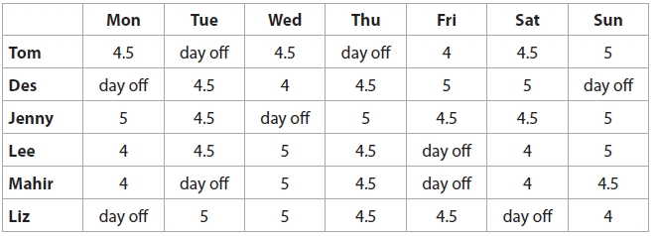
Mahir is paid an hourly rate of £7.85
(a) How much is Mahir paid for working last week?
Show a check of your working. (4)

