Card D (9 marks)
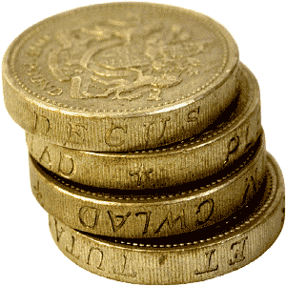
Last year, Mona spent:
- 30% of her salary on rent
- 2/5 of her salary on entertainment
- ¼ of her salary on living expenses
- She saved the rest of her salary
She spent £3,600 on living expenses.
Work out how much money she saved.

Savings: ______________

Card D (9 marks)
Last year, Mona spent:
- 30% of her salary on rent
- 2/5 of her salary on entertainment
- ¼ of her salary on living expenses
- She saved the rest of her salary
She spent £3,600 on living expenses.
Work out how much money she saved.

Savings: ______________

Mark Scheme, Card D
YOU CAN ONLY GAIN THE MARK IF YOU HAVE SHOWN THE WORK CLEARLY!
Finding total salary:
2 marks: ¼ = £3,600
£3,600 x 4 = £14,400
(if wrong total found, dock one mark but use new total for remaining calculations)
Spending:
2 marks: 30% of £14,400 -> 10% = £1,440
30% = 3 x £1,440 = £4,320
2 marks: 2/5 of £14,400 -> 1/5 = £2,880
2/5 = £5,760
Finding savings:
2 marks: £4,320 + £5,760 + £3,600 = £13,680
£14,400 - £13,680 = £720
Answer box:
1 mark: £720

ALTERNATIVE – full marks available
Groups may convert all amounts to fractions or percentages, then find 1/20 or 5% of total or find 1/5 of £3,600 without finding the total. Work MUST be clear.

