Card A (6 marks)
Liam looks at two different offers for an iPad.
Amazon.co.uk
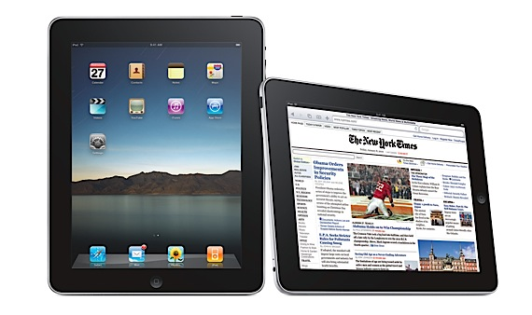
30% off Normal price £390
Apple Store
1/3 off Normal price £405

Which store sells the iPad more cheaply? You must show your working out.

Cheaper store: _____________

Card A (6 marks)
Liam looks at two different offers for an iPad.
Amazon.co.uk
30% off Normal price £390
Apple Store
1/3 off Normal price £405

Which store sells the iPad more cheaply? You must show your working out.

Cheaper store: _____________

Mark Scheme, Card A
YOU CAN ONLY GAIN THE MARK IF YOU HAVE SHOWN THE WORK CLEARLY!

Amazon
1 mark: 30% of £390 = £117
1 mark: £390 - £117 = £273
Apple Store
1 mark: 1/3 of £405 = £135
1 mark: £405 - £135 = £270
Comparison:
1 mark: Show £273 (amazon) > £270 (apple)
Answer box:
1 mark: Apple

