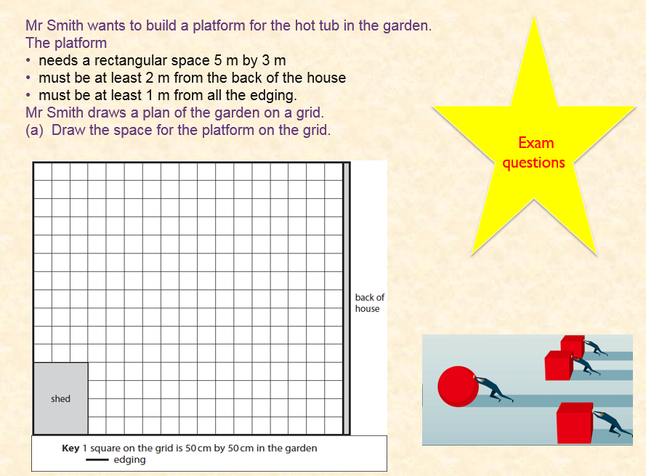
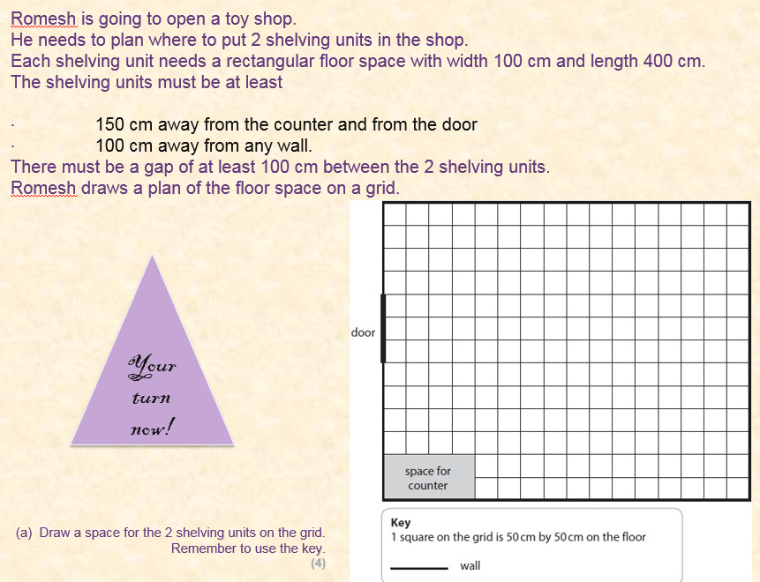
Exam questions L1

Q1. Rashid is going to buy a table and a display unit.
He wants to work out where to put them in his dining room.
The table needs
• a rectangular space 200 cm by 150 cm.
The display unit needs
• a rectangular space 1 m by m
• the longest side against a wall.
Draw the table and display unit on the plan for Rashid.
(4)
Key: 1 square on the grid is 50 cm by 50 cm in the dining room

(Total for question = 4 marks)

Q2. Tim wants to put two sofas in the shed.
He draws a plan of the floor space on this grid.
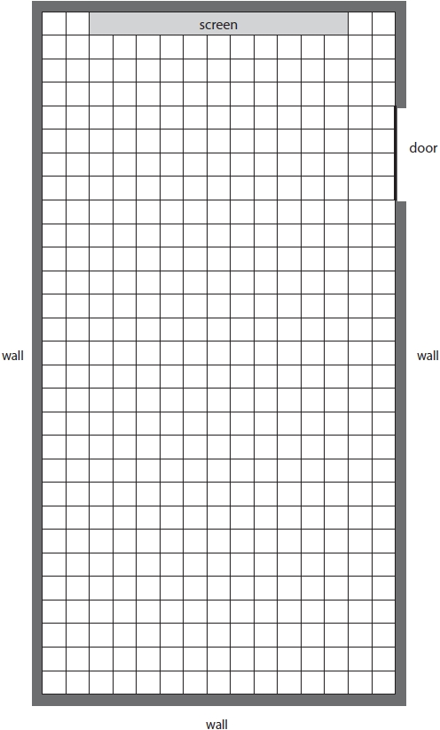
Key: 1 square on the grid is 25 cm by 25 cm on the floor of the shed.
Each sofa needs a rectangular space 2 m by 1 m.
There must be a gap of at least
• 75 cm between any sofa and the walls
• 50 cm between sofas
• 3 m between the screen and the sofa nearest to the screen.
The longest side of each sofa must face the screen.
Draw the space for each sofa on the grid. (4)
Q3.
Laura is going to put the play house in her garden.
The play house needs
• a rectangular space 150 cm by 200 cm
• to be at least 1 m away from the sand pit.
Laura draws a plan of her garden on a grid.
(b) Draw a space for the play house on the grid.
Remember to use the key.
(3)
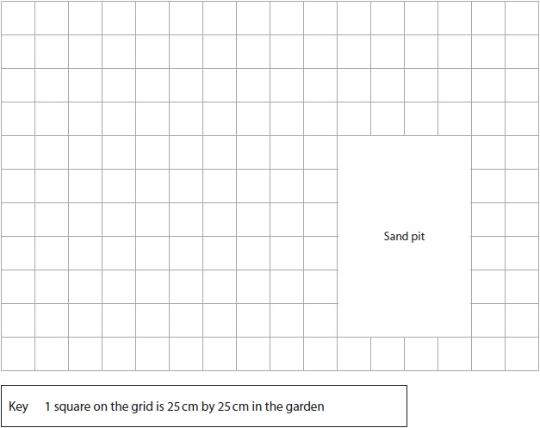

Q4.
Eric wants to put some hair washing stations in a different room.
A washing station needs one sink and one chair.

The chair needs:

• a rectangular space 60 cm wide and 110 cm long
• one of its shorter sides to go along a side of the sink
• to have at least 50 cm of free space around its other sides.

Eric starts to draw a plan of one washing station on a grid.
(b) Draw a space for the chair on the grid. (3)

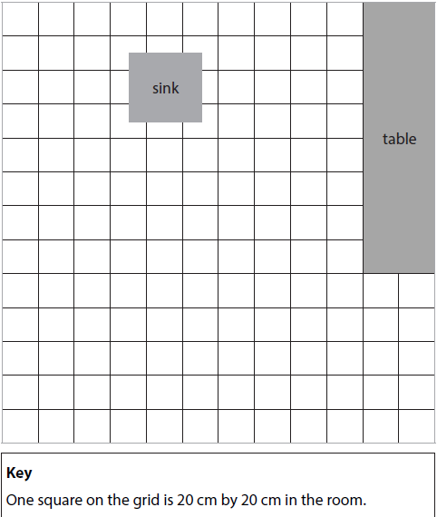

Q5.
Sajid wants to put a desk and a coffee table in his new office.

The desk is in the shape of a rectangle 100 cm by 160 cm.
Sajid wants to put the desk:

• against a wall
• at least 60 cm away from the window.

The coffee table is in the shape of a square with side length 80 cm.
He wants 40 cm of clear space around the coffee table.
Sajid draws this plan of the office on a grid.
