Probability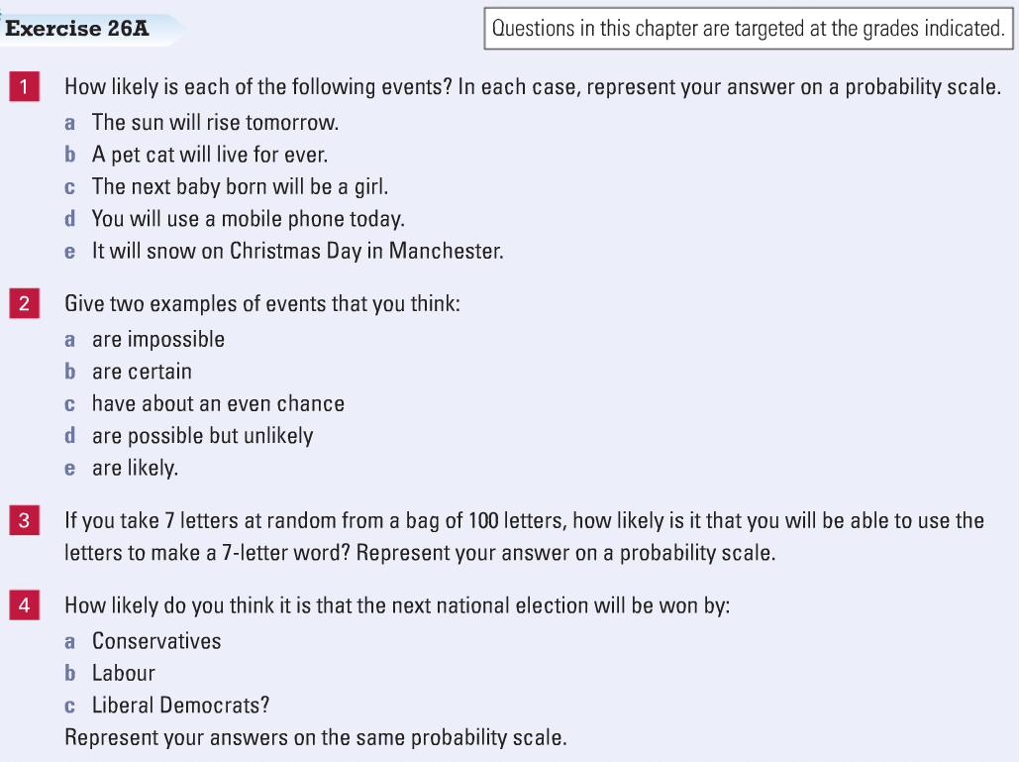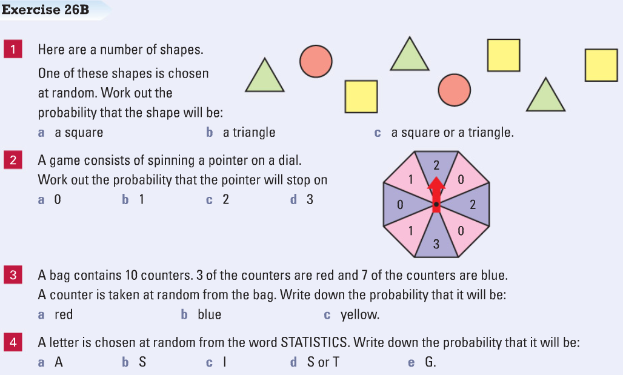
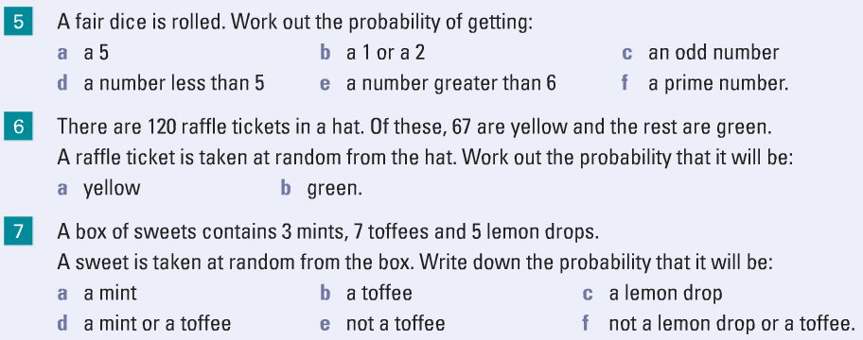
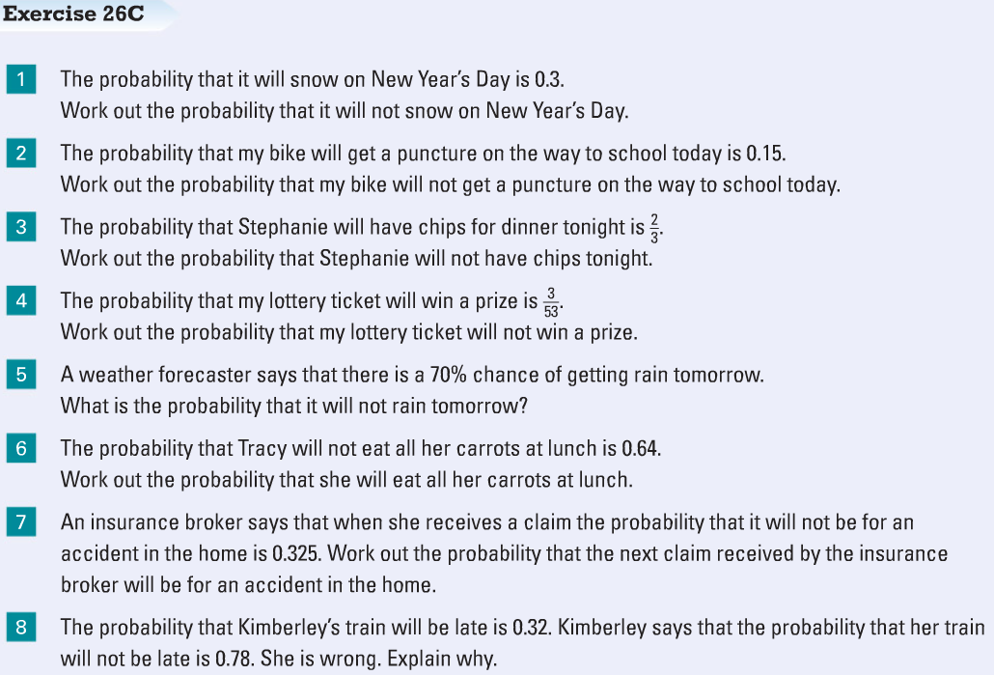
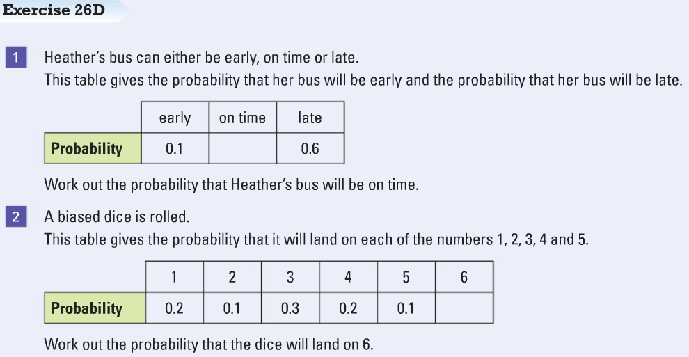

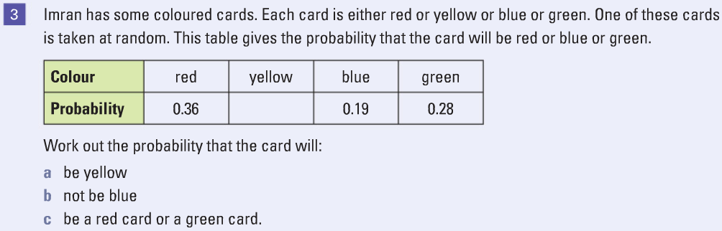
Probability 1 check-up

Classify these future events under the headings:
Impossible, unlikely, equal chance, likely, certain

It will rain tomorrow. | I will win the lottery this weekend. | I will walk to France in the summer. | The sun will rise on Friday. | If I toss a coin it will come up heads.
If I roll a die it will come up with an odd number. | Next week the day after Monday will be Tuesday. | Next year the first month will be March. | Next year Christmas Day will be in December. | My birthday will never be at the weekend.
Stretch and challenge

Exam Questions L2

Q1.

Jane buys the compost from a garden centre.
The checkout assistant sells tickets for a prize draw.
Jane buys 5 tickets.
1000 tickets are sold in total.
One ticket picked at random will win a prize.
(b) What is the probability that Jane will win the prize?
Write your answer as a fraction in its simplest form.
(2)
Use the space below to show clearly how you get your answer.

Q2.

Jenny is an assistant manager in a leisure centre.
She asks some of the leisure centre users to complete a questionnaire.
The questionnaire was completed by
- 25 people who were swimming
- 8 people who were playing squash
- 11 people who were in a fitness class.
Jenny picks one of the questionnaires at random.
What is the probability the questionnaire was completed by a person who was playing squash?
(2)
Use the space below to show clearly how you get your answer.

Exam question L1
Can I list all possible outcomes of an event or events?

Q1.
The Leyland team will play the Buckshaw team in the squash tournament.
Kathy is the team captain for Leyland.
There are 3 players in each team.
Each player from Leyland plays one game against each player from Buckshaw.
Kathy wants to make a list of all the games in the tournament.
The first game is Andi against Rachel.
(b) Make a list of all the games for Kathy.
(3)
Write your list in the space below.

